Contents

Admin login with valid details 2

Admin login with invalid details 2

View dashboard 3

View Shops and Products 4

View daily report on orders of all traders 5

View monthly report on orders of all traders 6

View weekly report on orders of all traders 7

## Admin login with valid details

Expected Result: Admin is directed to dashboard

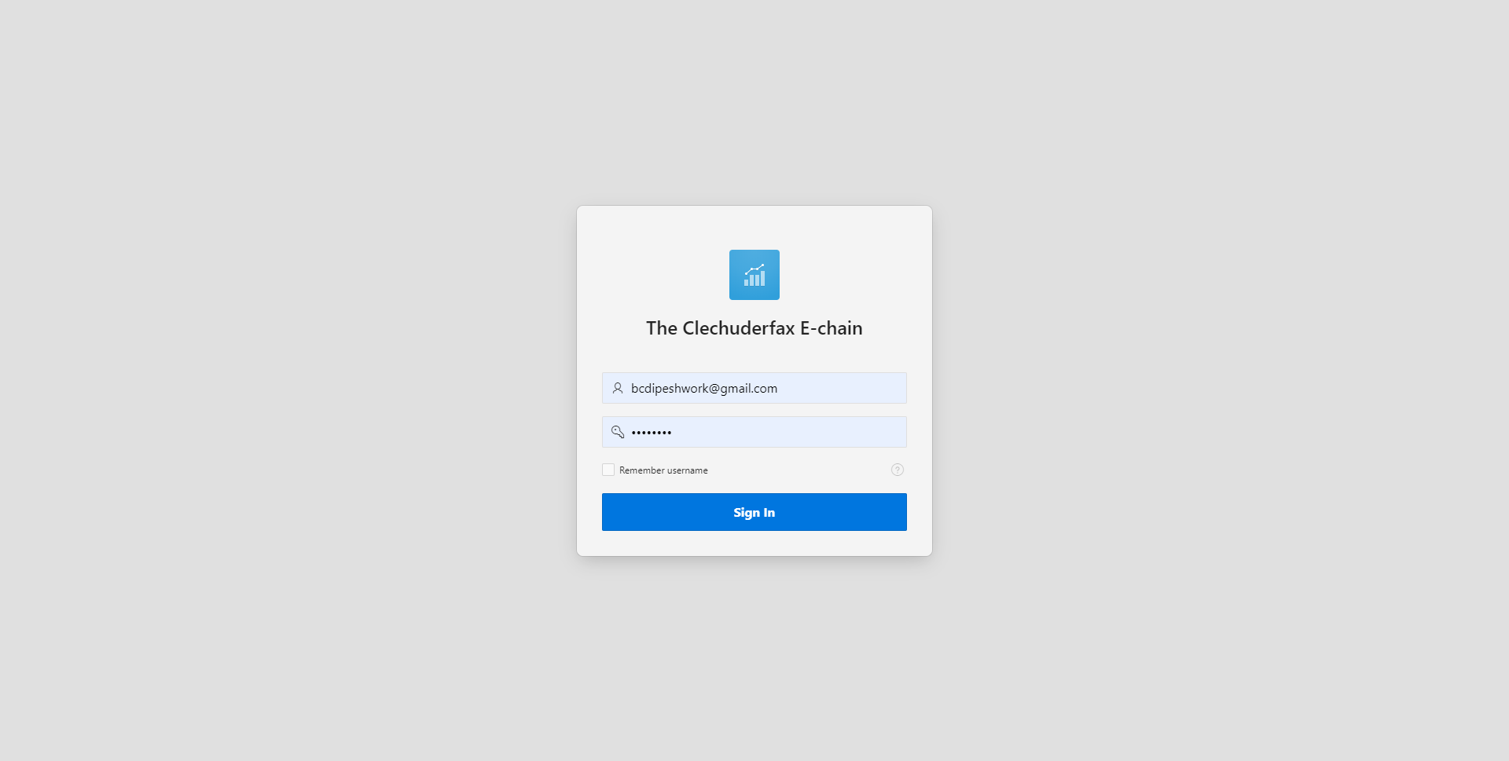

## Admin login with invalid details

Expected Result: Error message is displayed, and login is disallowed

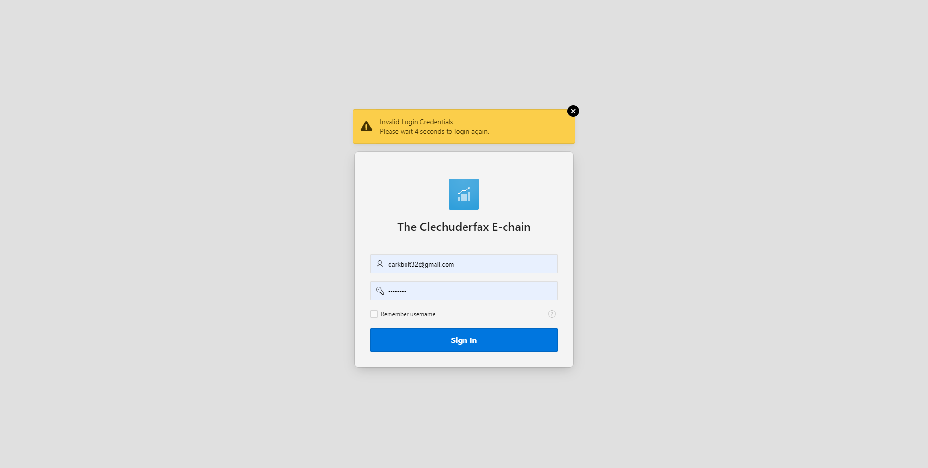

## View dashboard

Expected Result: A dashboard is shown showing summary of details

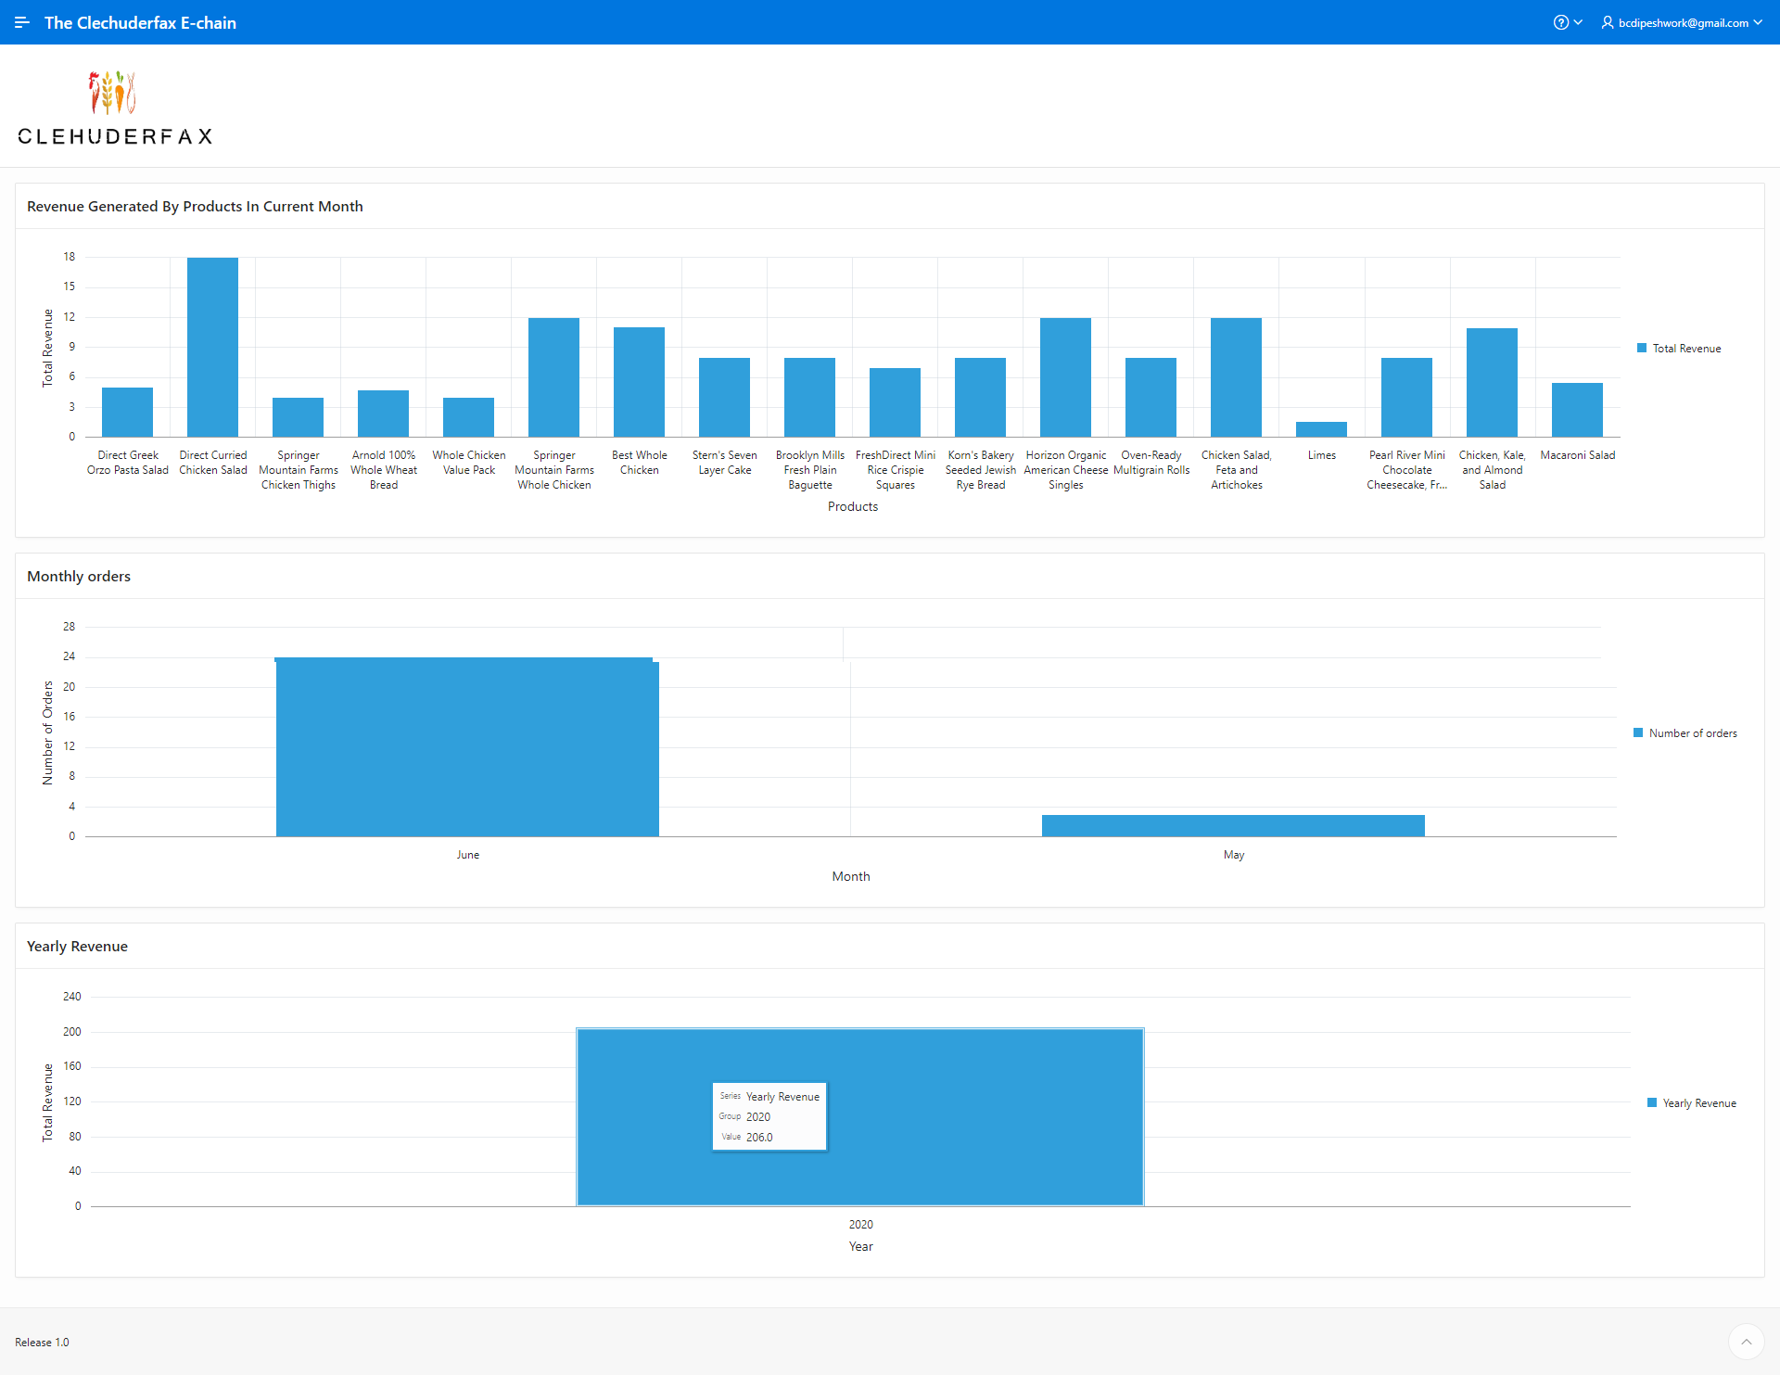

## View Shops and Products

Expected Result: An admin can view shops and products available in that shop

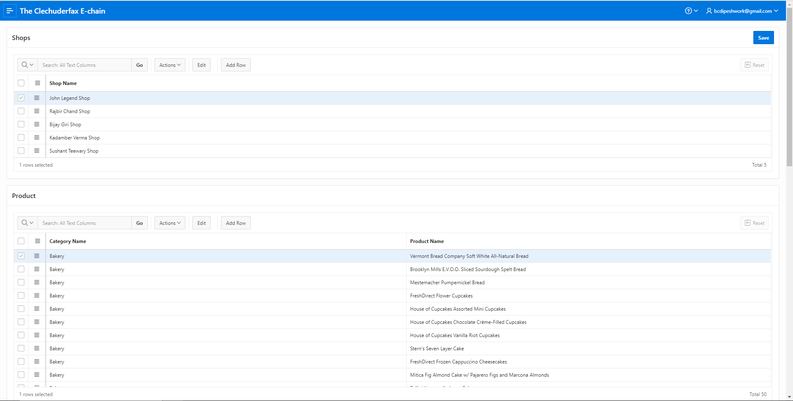

## View daily report on orders of all traders

Expected Result: A report customer details, invoice details, collection slot details and payment details is shown.

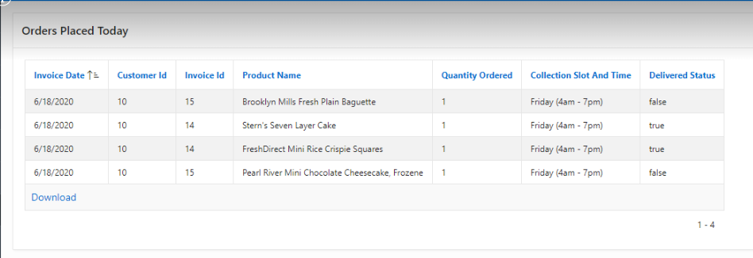

## View monthly report on orders of all traders

Expected Result: A monthly report with product details, total income, quantity, invoice date and month is shown.

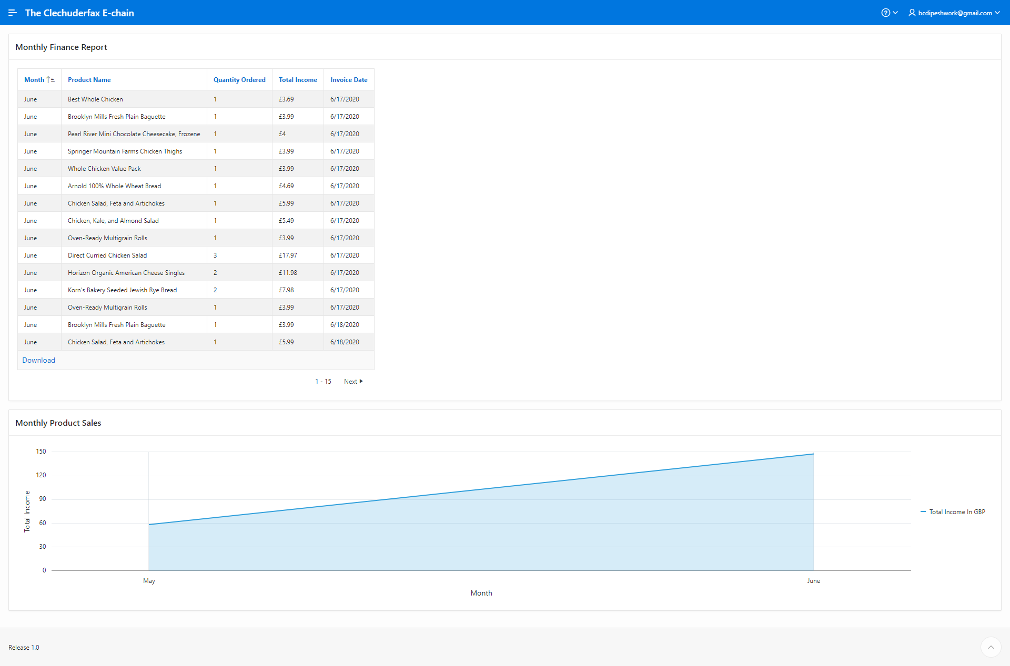

## View weekly report on orders of all traders

Expected Result: A weekly report with product details, total income, quantity, invoice date and month is shown.

